QA Testing Engineer Profile Test (Behave, Selenium, SQL, Python, testing knowledge)

This test was built in 3 parts, a functional one with requirement analysis, automation, SQL Databases basics and some questions about software testing.

Part 1:

* With the following scenarios, automate the interaction. For this you should use whether version of the listed frameworks you like: Python and selenium.
  1. Scenario 1: User can search with “Google Search”
     + Given I’m on the homepage
     + When I type “test automation” into the search field And I click the Google Search button
     + Then I go to the search results page, and the first 3 results contain the word “automation”
  2. Scenario 2: User can go to the first search result
     + Given I Search by keyword
     + When I click on the first result link
     + Then I go to the page, and the page title contains the word “automation”

Guidelines:

You are testing https://www.google.com.

Always make use good principles and practices when designing your Solution.

Implement your automation solution, if possible, following the Page Object Model pattern and BDD paradigm.

Part 2 (SQL Basic Scripting):

1. Explain the difference, in databases, between ‘Having’ and ‘where’ when it comes to a query. Develop one example for each one of this two cases and point out the difference.

The difference between Having and Where clauses is, ‘Where’ is applied to the individual rows in the tables, and only show us the rows that meet the conditions applied in the ‘Where’, but ‘Hanving’ is applied to the rows in the result set for this case when a condition 'where' meet them and they are called groups, the 'Having' condition only we can use it when appear the 'GROUP BY' clause or in an aggregate function

Example

1.SELECT Employees.LastName, COUNT(Orders.OrderID) AS NumberOfOrders  
2. FROM Orders  
3. INNER JOIN Employees ON Orders.EmployeeID = Employees.EmployeeID  
4. WHERE LastName = 'Montoya' OR LastName = 'Corral'  
5. GROUP BY LastName  
6. HAVING COUNT(Orders.OrderID) > 25;

In the line 1, the SQL statement start by selecting the Employees.LastName Column making a grouping in a count of the orders that the employee has in Orders.OrderID column that will be called NumberOfOrders.

In the line 2, that SQL Statement will be applied on Orders table.

In the line 3 it tell us that only will bring the results that match with the EmployeeID between Orders and Employees tables.

In the line 4, The SQL Statemen will do a data filter with the clausule 'Where ' of the LastName column is Montoya or Corral

In the line 5, the result are going to be grouped in the LastName column.

In the line 6, the final result only will show us the Employees that have more of 25 orders

Result

|  |  |
| --- | --- |
| LastName | NumberOfOrders |
| Montoya | 26 |
| Corral | 45 |

1. Write a query for create a data table ‘Student’ with the following attributes in it: ‘Name, ‘Code, ‘Class’, ‘Age’, ‘Favorite Subject, ‘GPA’ (5.0 scale).

CREATETABLE [dbo].[Student](

      [Name] [varchar](50) NOTNULL,

      [Code] [int] NOTNULL,

      [Class] [varchar](50) NOTNULL,

      [Age] [int] NOTNULL,

      [Favorite_Subject] [varchar](80)NOTNULL,

      [GPA] [decimal](5,0) NULL,

 );GO

1. Insert at least 40 records in the last table with close to real data.

INSERT INTO Student (Name, Code, Class, Age, Favorite_Subject, GPA)

VALUES

(Dario, 1, Math, 20, Listen music, 5.0),

(Juan, 10001, Math, 30, Fishing, 1.3),

(Selene, 10003, Music, 18, Listen music, 4.2),

(Andres, 10004, Sports, 17, Read book, 4.5),

(Diego, 10005, Gym, 15, Watch movies, 2.2),

(Martin, 10006, Philosophy, 34, Fishing, 1.9),

(Sammuel, 10007, Statistics, 23, Swiming, 3.3),

(Miguel, 10008, Economy, 27, Listen music, 4.7),

(Maricel, 10009, Geometry, 10, Read book, 4.5),

(Aura, 10010, Geography, 31, Watch movies, 2.9),

(Robertulio, 10011, Math, 30, Fishing, 3.1),

(Stiven, 10012, Spanish, 21, Swiming, 4.8),

(Ehudes, 10013, Music, 18, Listen music, 4.5),

(Jose, 10014, Sports, 17, Read book, 1.5),

(Daniela, 10015, Gym, 15, Watch movies, 3.9),

(Juliana, 10016, Philosophy, 34, Fishing, 4.7),

(Olmedo, 10018, Economy, 27, Listen music, 3.8),

(Deyci, 10019, Geometry, 10, Read book, 2.9),

(Sandra, 10020, Geography, 31, Watch movies, 1.9),

(Felipe, 10021, Math, 30, Fishing, 1.7),

(Mariano, 10022, Spanish, 21, Swiming, 3.7),

(Marina, 10023, Music, 18, Listen music, 4.7),

(Milena, 10024, Sports, 17, Read book, 5.0),

(Cristina, 10025, Gym, 15, Watch movies, 2.2),

(Rosalba, 10026, Philosophy, 34, Fishing, 1.6),

(Orlando, 10027, Statistics, 23, Swiming, 3.9),

(Ximena, 10028, Economy, 27, Listen music, 4.6),

(Jhon, 10029, Geometry, 10, Read book, 3.5),

(Patricia, 10030, Geography, 31, Watch movies, 2.8),

(Nelly, 10031, Math, 31, Fishing, 3.7),

(Isabela, 10032, Spanish, 30, Swiming, 4.8),

(Janeth, 10033, Music, 21, Listen music, 5.0),

(Mauricio, 10034, Sports, 18, Read book, 1.9),

(Rodolfo, 10035, Gym, 17, Watch movies, 3.9),

(Hector, 10036, Philosophy, 15, Fishing, 4.4),

(Esneira, 10037, Statistics, 34, Swiming, 5.0),

(Daliana, 10038, Economy, 23, Listen music, 3.3),

(Hanna, 10039, Geometry, 27, Read book, 2.1),

(Camila, 10040, Geography, 10, Watch movies, 1.8),

(Daniel, 10002, Spanish, 21, Swiming, 3.3);

1. Write a query to get the average of the GPA from all the students which name starts with ‘A’.

Select AVG(GPA)

from Student

HAVING GPA > 4.7

1. Write a query to get the list of students that are in the same class, have a GPA higher than 3.5/5.0 and order them by Age and Name.
2. Write a query to get the list of all the students with ‘Name, ‘Code, ‘Class’, ‘Age’, ‘Favorite Subject, ‘GPA’.

Select *

from Student

1. Take the following 25 question quiz about SQL, please include a screenshot about the results and time it took to take the test.

<http://www.w3schools.com/quiztest/quiztest.asp?qtest=SQL>

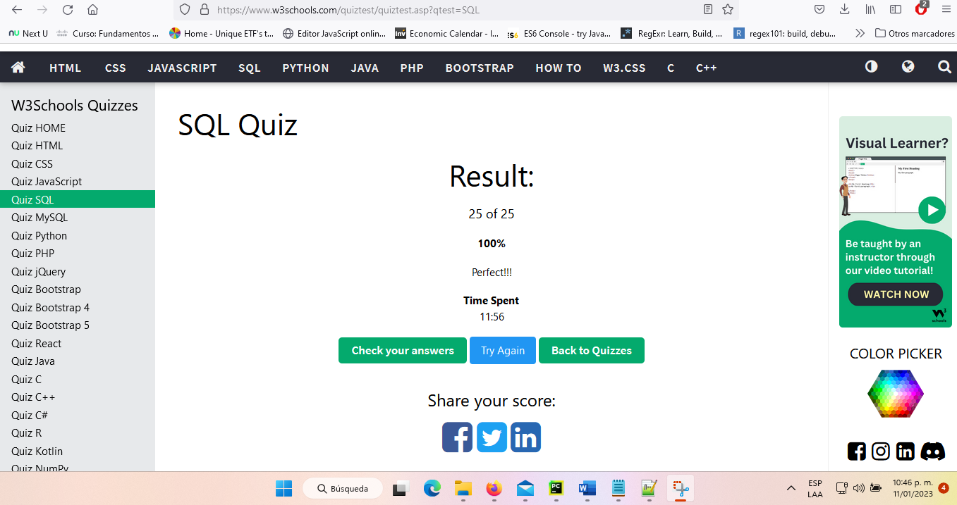

Part 3 (Software Testing Knowledge):

1. What is the difference between a unit test, an acceptance test, an integration test and an end-to-end test?

Unit test is called the white box and its goal is to make sure that a specific module works under all condition required.

The Acceptance test its goals is quality assurance process that determines if the requirements of a specification or contract are met.

The integration test its goal is to make sure that the interface between modules are doing it expect.

And The end-to-end test its goal is simulate a real user scenario making double-check verifying if everything works.

1. Could you explain Cohn's automation pyramid?



The Base Layer or the Unit Test its goal is give the programmer very specific information about the origins of a bug, up to the exact line of code where a failure occurs.

The Middle layer or API tests its goal is for those tests that exceed the scope of unit tests it is strongly advised to use tests that communicate with the application under test at the service or API level.

The top layer or GUI Test is where UI-Level automated tests reside, they are often the most brittle and take the longest time both in test case development and in test execution

1. Could you explain the difference between a black box testing and a white box testing?

The difference between both are that Black box is a software testing methodology where a tester analyzes application functionality without a through knowledge of its internal design, however the white box is a software testing methodology where a tester with knowledge of the application internal working is leveraged during testing.

1. What is the purpose of an exploratory test and when is it useful to run them?

Exploratory testing is often described as software testing for continuos learning on test design, and execution. Its goal is to allow of the individual tester to uncover defects that are not easily covered in the scope of other tests.

This process should always be done

1. Mention at least 5 test design techniques and explain them briefly
2. What is the purpose of the following types of tests?
   1. Functional test: The purpose of Functional tests is to test each function of the software application, by providing appropriate input, verifying the output against the Functional requirements.
   2. Performance test: Its purpose is make test to determine how a system performs in terms of responsiveness and stability under a particular workload.
   3. Security test: Its purpose is reveal flaws in the security mechanisms of an information system that protect data and maintain functionality as intended.
   4. Usability test: its purpose is to evaluating a product or service by testing with a represent user who will try complete typical task and will wait the wish results
   5. API test: The purpose of API Testing is to check the functionality, reliability, performance, and security of the programming interfaces
   6. Unit Test: is a type of software testing where individual units or components of a software are tested.

References:

* <https://www.softwaretestinghelp.com/the-difference-between-unit-integration-and-functional-testing/>
* <https://stackoverflow.com/questions/7672511/unit-test-integration-test-regression-test-acceptance-test>
* <https://www.softwaretestinghelp.com/what-is-end-to-end-testing/>
* <https://www.testingexcellence.com/exploratory-testing-important-agile-projects/>
* <https://www.guru99.com/exploratory-testing.html>
* <http://softwaretestingfundamentals.com/differences-between-black-box-testing-and-white-box-testing/>
* <https://smartbear.com/solutions/api-testing/>
* <http://softwaretestingfundamentals.com/security-testing/>
* <https://www.guru99.com/what-is-security-testing.html>
* <https://www.experienceux.co.uk/faqs/what-is-usability-testing/>
* <https://en.wikipedia.org/wiki/API_testing>
* <https://en.wikipedia.org/wiki/Application_programming_interface>
* <https://searchsoftwarequality.techtarget.com/definition/performance-testing>
* <https://www.guru99.com/performance-testing.html>
* <https://www.tutorialselenium.com/2017/05/28/como-usar-selenium-ide/>
* <https://cleventy.com/tutorial-selenium-primeros-pasos/>
* <http://www.juntadeandalucia.es/servicios/madeja/contenido/recurso/381>
* <https://www.tutorialselenium.com/2017/09/24/como-usar-comandos-de-selenium-ide/>
* <https://testeandosoftware.com/selenium-comandos-selenese/>
* <https://www.seleniumhq.org/selenium-ide/docs/en/introduction/getting-started/>
* <http://www.cs.tau.ac.il/~amiramy/SoftwareSeminar/CTDmay2012.PDF>
* <https://www.guru99.com/decision-table-testing.html>
* <https://www.toolsqa.com/software-testing/decision-table-testing/>
* <https://www.tutorialspoint.com/software_testing_dictionary/data_flow_testing.htm>
* <https://www.javatpoint.com/data-flow-testing-in-white-box-testing>
* <https://www.thedigitalmentor.com/what-is-dataflow-testing/>
* <https://en.wikipedia.org/wiki/Boundary-value_analysis>
* <https://www.guru99.com/equivalence-partitioning-boundary-value-analysis.html>
* <https://www.testingexcellence.com/boundary-value-analysis/>
* <http://www.professionalqa.com/combinatorial-testing>
* <https://en.wikipedia.org/wiki/Classification_Tree_Method>
* <https://www.expleo-germany.com/en/products/testona/classification-tree-method/>
* <https://inf.mit.bme.hu/sites/default/files/materials/taxonomy/term/445/13/04_Testing.pdf>
* <https://www.bcs.org/upload/pdf/amettehass-131211b.pdf>
* <https://www.bcs.org/upload/pdf/amettehass-131211a.pdf>
* <https://www.tutorialspoint.com/software_testing_dictionary/pdf/test_case_design_technique.pdf>
* <https://testautomationresources.com/software-testing-basics/software-test-design-techniques/>
* <https://www.uio.no/studier/emner/matnat/ifi/INF3121/v18/forelesningsvideoer/chapte-4-part-2-slides.pdf>
* <http://tryqa.com/what-is-test-design-technique/>
* <http://tryqa.com/what-is-structure-based-technique-in-software-testing/>
* <http://tryqa.com/what-is-black-box-specification-based-also-known-as-behavioral-testing-techniques/>
* <http://tryqa.com/what-is-white-box-or-structure-based-or-structural-testing-techniques/>